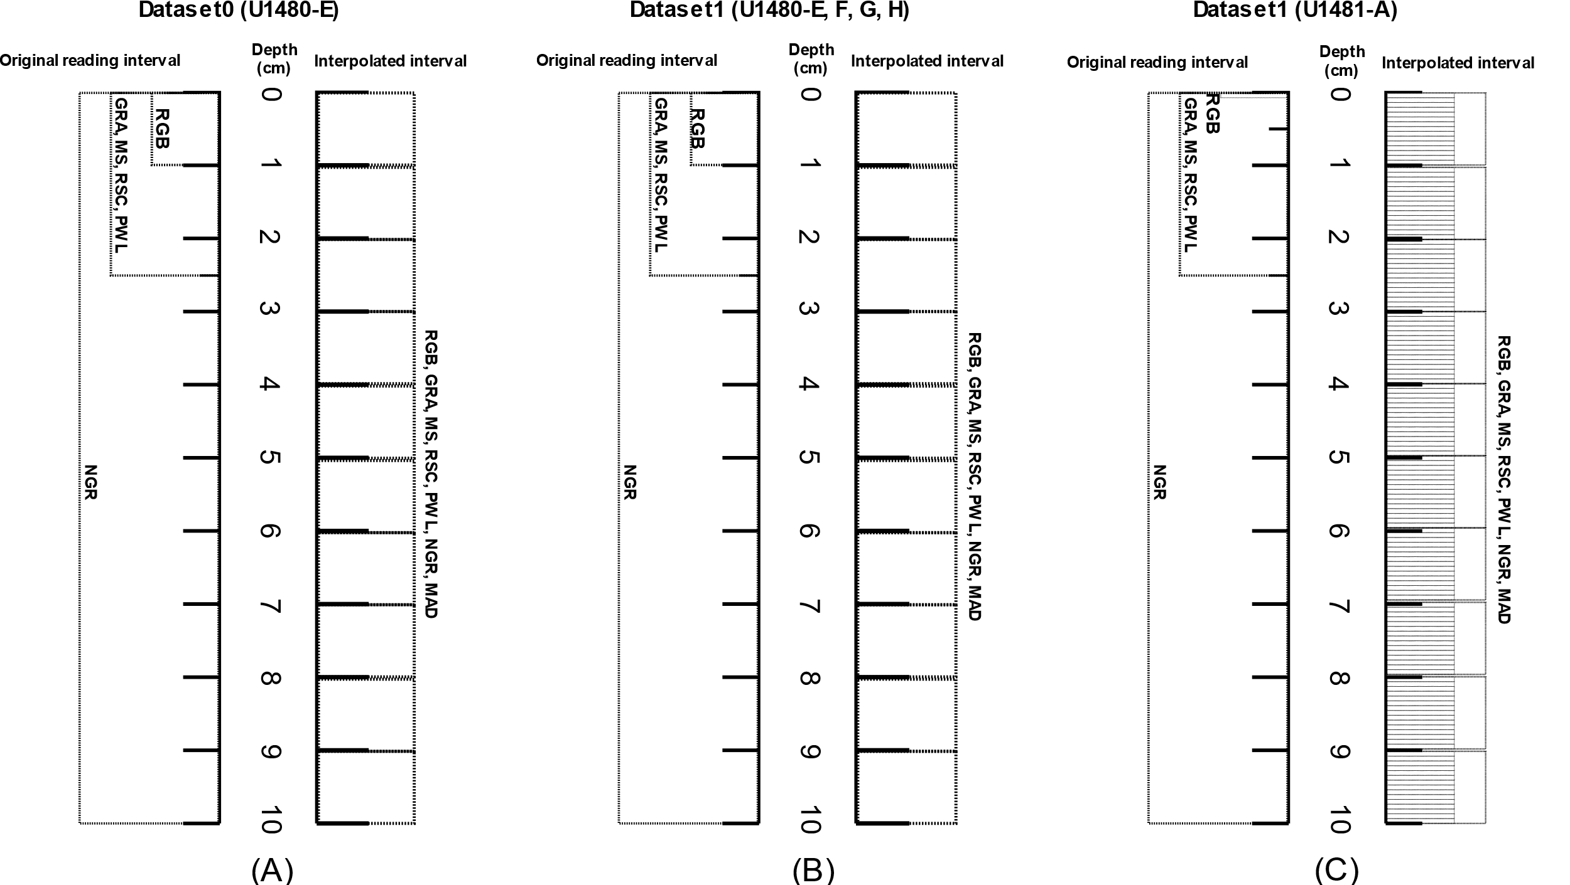

Figure 1 Original reading interval of the geophysical properties according to the formation of the dataset. Dataset0 is formed by the original values of the geophysical properties GRA, MS, RSC, PWL, NGR and RGB with values interpolated at a depth of 1 cm on site U1480, Hole E. Dataset1 (B) is formed by the original values of the geophysical properties GRA, MS , RSC, PWL, NGR and RGB with values interpolated at a depth of 1 cm on site U1480, Holes E, F, G, H. Dataset1 (C) is formed by the original values of the geophysical properties GRA, MS, RSC, PWL, NGR and RGB with values interpolated at a depth of 0.04 cm and 1 cm at site U1481, Hole A. Original value for the MAD geophysical property follows a different reading pattern than other properties.

Table: Interpolation intervals separated at site U1480 and site U1481 using the defined interpolator. The lowest reading resolution on the sites U1480 and U1481 is in the RGB geophysical property.

|  |  |  |  |
| --- | --- | --- | --- |
| **Site** | **Interpolador** | **Depth range for interpolation** | **Lower reading resolution** |
| U1480 | Akima | 1,00 cm | 1,00 cm |
| U1481 | Akima | 1,00 cm | 0,04 cm |